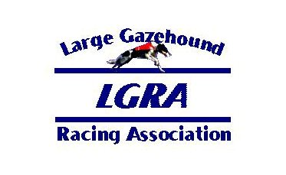
Club: Date:

Breed:

QUICK ENTRY (For dogs that have previously raced in LGRA events):

LGRA NO: CALL NAME:

LGRA NO: CALL NAME:

LGRA NO: CALL NAME:

FTE (First Time Entered Dogs):

CALL NAME: SEX:

REGISTERED NAME (Include titles):

SIRE:

DAM:

REGISTRATION PAPERS ATTACHED: AKC UKC NGA AKC ILP OTHER

FTE (First Time Entered Dogs):

CALL NAME: SEX:

REGISTERED NAME (Include titles):

SIRE:

DAM:

REGISTRATION PAPERS ATTACHED: AKC UKC NGA AKC ILP OTHER

I and my heirs, legal representatives and assigns shall hold harmless and defend from any claim for personal injury, illness or property damage arising out of participation in this race meet sponsored by
, its officers, directors, committees, agents and members, and the Large Gazehound Racing Association, its officers, directors, committees, agents, and members. I agree to abide by the Official Rules and Regulations of LGRA and its code of conduct during this race meeting.

Signature of Owner Date

Owner’s Name (please print)

Address

E-mail Phone

